COMP2511: Object Oriented Programming

Introduction to Java:

* Platform independence: Solved the problem at the time where different binaries were only compatible to certain machines with C code.
  + Write once (machine independent) 🡪 Run multiple times across multiple platforms
* Each platform needs a virtual machine (Java runtime environment) to run the byte code

Differences between Java and C:

* No explicit pointers
* Automatic memory management 🡪 Automatic garbage collection for unused memory
* Java compilers 🡪 Just in time java compilation can result in speedup over static C compilers
* Java multithreading is in base Java, whilst you need libraries for C
  + Just in time compilation + multithreading can result in faster Java code that optimises based on multithreading
  + Increasingly, Java is actually more performant than C

Design paradigms: see “Designing a class” (below)

Types of Programming:

* Procedural programming:
  + Action oriented
  + Groups of actions are formed into functions and functions are grouped to form programs
* OOP:
  + Create user-defined types called classes.
  + Classes contain data about the entity it represents and the methods that manipulate the data
  + Object: Instance of a user-defined type (i.e. instance of a class)
    - OOP encapsulates data (attributes) and methods (behaviours) into objects
    - Have the properly of information hiding

Inheritance:

* New classes (subclasses) are created from existing classes by absorbing their attributes and behaviours
  + Subclass: Extends the super class. Adds behaviours, properties, etc. from the super class
  + Things common between entities inherit those common properties from the super class
* Inheritance relationships form a tree-like hierarchical structure
* Method overwriting: Methods are defined by the closest method to the current class instance

Relationships:

* “Is-A” Inheritance relationship:
  + An object of a subclass is treated as an object of the super class
  + Use inheritance to model an “Is-A” relationship
    - DON’T USE inheritance unless it makes sense to do
    - E.G. Mathematically circles are a subset of all ovals. However, a circle class shouldn’t inherit from an oval class because an oval class can have methods to setHeight and setWidth 🡪 These attributes and methods conflict with the definition of a circle
* “Has-A” Association relationship:
  + Class object has an object of another class to store its state or do its work
    - “Has-A” reference to another object
  + These relationships are examples of creating new classes by composition of existing classes

Designing a class:

* Consider the functionality, different ways the object can be created, properties of data, etc.
* Always try to keep data private (local)
  + Only accessible through methods
* Break up classes with too many responsibilities.
  + Consider factoring out common attributes & behaviours between multiple classes into a superclass
  + Then use suitable “Is-A” or “Has-A” relationships

Domain Modelling using UML:

* Designing and modelling classes are one of the most important practices in OOP
  + How do we model the inter and intra-module relationships
    - Relationships between classes that comprise a module
    - Relationships between the modules themselves
  + How should the methods that interact between classes work?
    - Classes may have class-independent data
* Universal Modelling Language: UML class diagrams to represent domain models
  + Assumptions 🡪 Users can’t communicate their exact requirements
    - Clarification document to client so you do not get screwed on the final demo.
  + Types of relationships in UML:
    - Dependency: A depends on B
    - Aggregation: A class contains another class.
      * A is associated with B. B persists even if A is deleted
      * More associated with physical resources
    - Composition: More restrictive aggregation, contained class is integral to the containing class. (cannot exist outside of the container)
      * A is associated with B. B loses meaning / is discarded when A is deleted
      * More associated with virtual objects / resources
    - Undirected Association: Does not assume dependence.
    - Directed Association: Indicated which class has knowledge of the other

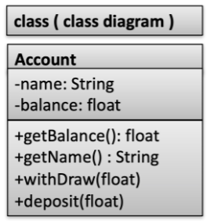

Figure 1 UML class representation

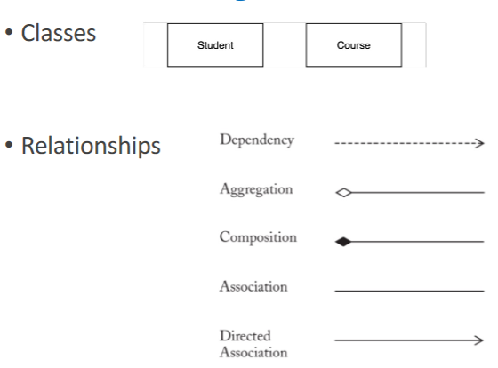

Figure 2 UML Diagram Syntax

* UML representations: see relationships above
  + Arrow: Inheritance = directed association
  + Add cardinality to relations (1:0..N, 1:1, etc.)
* Domain Models: Visually represent domain concepts and the relationships between them
  + Requirements analysis 🡪 External behaviour
    - Features and actors within the system
  + Domain modelling 🡪 Internal behaviour
    - How the components of the system produce the expected behaviour
  + ^ The two above concepts are mutually dependent
  + High-level abstractions should be used instead of technical details (low-level)

Attributes vs Classes:

* Should something be an attribute or a class?
  + If it cannot be represented by a primitive type (number, string) 🡪 Likely should be represented by a class

Approaches to subclasses and inheritance:

* Philosophy: Don’t duplicate code, replace duplication with relationships
  + “Has-A”: Uses method forwarding (methods from the has-a class to define some new methods)
  + “Is-A”: Extends super methods, modifications to super class propagate to your implementation
* Abstract class: Define framework of methods in super-class that acts like a common interface across all subclasses
* Interface: Classes that implement interfaces must implement all the interface functionality

Polymorphism: An object’s ability to decide what method to apply to itself, depending on where it is in the inheritance hierarchy

* Objects can be cast as the abstract class or the interface it implements, and these casting can result in different behaviours for the same method
* Dynamic binding: Methods are bound to objects after creation 🡪 Even after it is cast to the superclass

Method forwarding:

* If a class implements an interface, we can reuse code from other classes that implement the interface - called method forwarding
* Create new class that corresponds to another class that implements the interface method --> "Has-A" Relationship
* Allows us to selectively choose methods --> Sometimes we don't want to inherit every method from another class.

Method overriding:

* Methods in a class override methods in the superclass if the methods have the same name, return type, and position of typed arguments.

Method overloading:

* A single method name can have multiple implementations by varying the arguments or return types

Constructor:

* Super classes’ no argument constructor is implicitly added if the first argument of the constructor is not a super() or this() call
  + Calls super() up to the default Object class in java
* Constructors are implicitly inserted into a class if they are not defined

**Good Design Principles:**

* Assume software requirements can and will change
  + Flexibility and extensibility to accommodate these changes
  + Maintainable, reusable, extensible design
* Design smell: Violation of key design principles. We want to avoid these!
  + Rigidity: Too difficult to change
  + Fragility: Breaks in many places when a single change is implemented
  + Immobility: Hard to reuse
  + Viscosity: Changes are easier to implement through ‘hacks’ over ‘design preserving methods’
  + Opacity: Difficult to understand modules
  + Needless complexity / Repetition: Start with readable code.. You don’t need to introduce unnecessary complexity to save like 2 CPU cycles
  + Divergent change: One class is commonly changed in different ways, for different reasons
    - This denotes that there is too much responsibility that is placed on the class
  + Shotgun surgery: Opposite to divergent change 🡪 Lots of small changes to a lot of different classes
    - High coupling for one purpose
* Characteristics of good software:
  + Coupling: How strongly software elements are connected to other elements
    - Interdependence between components, high coupling = dependence on the internal workings of another component
    - Aim for loose coupling: Independent modifications and usage
  + Cohesion: How related the responsibilities of the software elements are within a software component
    - The degree to which all elements of a component or class work together
    - If many modules call a class
  + Loose coupling & high cohesion is good
* Test-driven development: Test cases before software 🡪 Immediate testing to make sure code is correct
* SOLID principles: General guidelines you might want to follow
  + Single responsibility principle: Many responsibilities in one class should probably be split
  + Open-closed principle: Open for extension, closed for modification
  + Liskov substitution principle: Objects in a program should be replaceable with instances of their subtypes without altering the correctness of the program
  + Interface segregation principle: Many client-specific interfaces are better than one monolith interface
  + Dependency inversion principle: One should depend on abstractions, not concretions

Law of Demeter: Principle of least knowledge. You (class) talk only to your friends

* Classes should know about and interact with as few classes as possible
  + Assume as little as possible about other classes 🡪 Information hiding
* Reduce interaction to ‘immediate friends’ and ‘local objects’ 🡪 Aids loose coupling within the system
* Friends comprise of:
  + Object itself and variables in the scope/global
  + Objects passes as parameters
  + Objects instantiated within the method
  + Any component objects
  + NOT objects returned by a method

How to solve problems without inheritance: Inheritance causes all the methods to be featured 🡪 Can be a lot of additional baggage that does not make sense to include

* Delegation: Delegate the functionality to another class
* Composition: Reuse behaviours using one or more classes with composition
  + Design principle: Favour composition over inheritance

Liskov Substitution Principle: Subtypes must be substitutable for their base types

* Things that sound right in English doesn’t necessarily translate to code
  + E.G. Square “Is-A” Rectangle
  + But setHeight and setWidth methods for Square don’t make sense to substitute for rectangle because it does unexpected behaviour (length of all sides instead of just height/width)

Figure 3 LSP example

Method Overriding: Rules

* Access level cannot be more restricted
* Static methods are not overridden, as they are associated with a class

Restructuring: Changing the internal structure of software

Refactoring: Restructuring software to make it easier to understand and cheaper to modify without changing its external, observable behaviour

* When to refactor? A general guide
  + Adding functionality 🡪 Makes it easier for future changes
  + Bugfix
  + Code review
* Methods should be allocated based on where it makes sense to utilise the information
  + If the majority of data comes from a class, consider migrating the method to that class
  + “Can this implementation be encapsulated within another context that makes more sense?”
  + Can consider branching based on an attribute in another class as bad 🡪 This can be encapsulated in the class that holds the data
* Prior Goals: Have verbose unit testing before Refactoring
* Post-Refactoring: Unit tests still pass
  + External behaviour doesn’t change, internals of the refactored code can be changed
* Degrees of refactoring:
  + Low Level
    - Moving around code, variable declarations for ‘magic numbers’
  + High Level 🡪 Mostly only if the current code is bad
    - Fundamentally changing the design patterns
    - Changing language idioms (safety, brevity)
    - Performance optimization
    - ^ Proper testing is especially important here
* <https://refactoring.com/catalog> --> Examples of refactoring changes

Why do we need design patterns?

* Abstract class (inheritance)
  + Need to suppress methods if not all subclasses can use the functionality
* Interface
  + No code reusability if multiple internal implementations are needed to implement the interface methods
* What do you do? Use design patterns!
  + Strategy Patterns: Type of design pattern where you define a family of classes, encapsulate each one and then make them interchangable
    - Use Interface variables as attributes for some guaranteed functionality. Functionality is defined in the implementing classes.
    - Pass in objects, don’t use strings w/ switch statements
    - Pass functionality into subclasses / objects, create new objects to abstract away combinations of objects
      * E.G. Car(new electricMotor(), new drivingSystem()) 🡪 Tesla()
      * Passing in objects that implement certain interfaces

Design Pattern: Tried solutions to commonly recurring problems

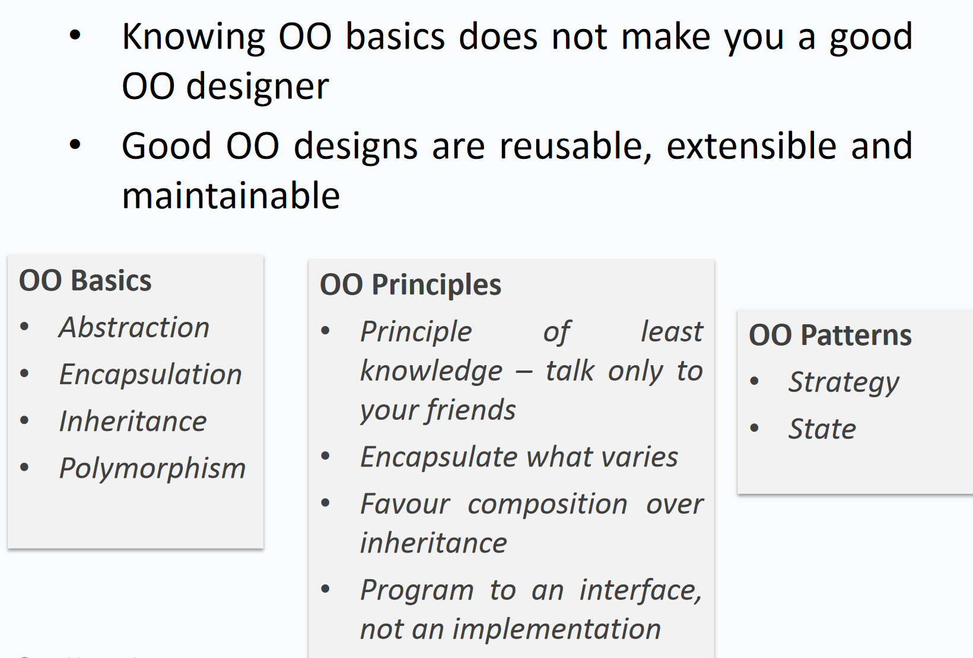

Figure 4 OOP Design Philosophy

State Pattern:

* Finite-State-Machine: Abstract machine that can be in exactly ONE state at a given time
  + Composed of: list of its states, conditions for transition and the initial state
* State: Description of the status of the system
* Transition: Set of actions when a condition is fulfilled / event is received
  + Identical stimuli trigger different actions depending on the current state
  + Entry and exit actions may be associated with transitioning to/from states
  + See State Transition Table (x: states, y:inputs 🡪 state change)

State-Machine uses:

* Frequently used in UI
  + Different aspect ratios
  + Event driven interface

Design Principles:

* Identify and encapsulate behaviours that have varying implementations
  + E.G. If flying can have different behaviours between different animals, we can encapsulate flying using a Flyable interface
  + Allows us to alter / extend the varying parts without affecting the parts that do not depend on that particular implementation detail
* Program to an interface, not an implementation
  + Program to a super type to allow for generalisation in the future
  + E.G. utilise dynamic binding
    - Dog d = new Dog(); d.bark(); 🡪 Change to 🡪 Animal d = new Dog(); d.makeSound();
  + Exploit polymorphism by programming to the super type
  + Behaviours 🡪 NO LONGER locked to a concrete implementation. Now we can use a set of “behaviour classes” that implement the interfaces. Classes are associated with behaviours and they do not need to know the implementation details

Figure 5 Design Pattern: Behavioural Interfaces 🡪 Implemented by a set of implementing classes

Figure 6 Integrating Instances with Behaviours

* Instance variable quackBehaviour and flyBehaviour are assigned based on what class of Duck
  + Implementing behaviours are assigned to instances
* HAS-A >>>> IS-A
  + Use **composition over inheritance** for behaviours

Strategy Pattern: Design pattern for the above duck example

* Motivation: You need to adapt the behaviour of an algorithm at runtime
* Intent:
  + Define a family of algorithms, encapsulate each one, and make them interchangeable
  + Strategy pattern is a behavioural design pattern that lets the algorithm vary independently from the context class using it
* Drawbacks: Increases the number of objects and relies on the client to be aware of the possible strategies
* Examples:
  + Sorting a list: Quicksort, bubblesort, mergesort, etc
  + Search: DFS, BFS, A*, etc

Figure 7 Implementation of a Strategy Pattern

Observer Pattern: Used to implement distributed event handling systems

* Use case: when you want to use event-driven programming.
* An object maintains a list of its dependents
  + Object 🡪 called a subject / observable / publisher
  + Dependents 🡪 called observers / subscribers
* Notifies observers automatically of any state changes in the subject

How can you maintain the observer pattern with dynamically allocated observers and subjects?

* Aims:
  + One-to-many dependency between objects without tight coupling
  + Automatically notify an unbounded number of observers when the subject changes state
  + Dynamically add and remove observers

Figure 8 Observer Pattern Possible Solution

* Subject:
  + Attach observer, detach observer, notify all observers
* Observer:
  + Update itself given a subject

Figure 9 Observer Pattern UML Example

Model View Controller (MVC):

* Model never directly connects with the view
* Consider the botnet
  + Controller is the interface which gets requests and returns the results of any function calls using the JSON arguments
  + Models is the database and the code that works on the database
  + View is the templates and user-facing display of the returned data

Figure 10 Model View Controller MVC

User Centred Design:

* Specify context of use
  + E.G. Amazon has a busy interface because they want to sell you lots of items, whilst Apple has a more minimalist design philosophy
  + Quality of experience is far more likely to be a product differentiator compared to product experience
* Specify requirements.
* Create design solutions
* Evaluate design

Composite Pattern: Aim is to manipulate a single instance of an object just as we would manipulate a group of them

* No discrimination between a single (leaf) object vs a composite (group) object
  + Composition of similar objects
  + E.G. Calculating size of file is the same as calculating the size of a directory
* Possible Solutions:
  + Uniformity: All child related operations are in the component interface
    - All the Leaf objects have the same interface as Composite objects, except the leaf objects don’t need to add children
    - Useful for dynamic structures where children types change dynamically (E.g. Leaf 🡪 Composite and vice versa)
  + Type Safety: Only define child related operations in the Composite class
    - Client treats Leaf and Composite objects differently
    - Useful for static structures where the child-related operations are not performed on unknown objects of type Component (E.G. through dynamic binding)

Figure 11 Composite Pattern: Type safety vs uniformity

Design by Contract:

* Responsibilities are clearly assigned to different software elements, clearly documented and enforced during development through unit testing/language support
  + Clear functionality demarcation helps prevent redundant checks
  + Simplifies code and makes maintenance easier
  + Can crash if required conditions are not satisfied
* Why use this design paradigm?
  + This is an alternative to **defensive programming**. We don’t write checks for everything to save on performance
    - Defensive programming might have overheads that are unnecessary for systems that do not need 24/7 availability
    - No clear demarcation between responsibility between components that all check the input
    - Makes maintenance more complex, then every client in the pipeline will need to be modified when input is changed
    - Advantage: Guarantees reliability, safety, security, etc.
  + In return, our software may break out of our specified responsibilities
* When does this apply?
  + E.G: Student grading example. If a Grade class has to go down a marking pipeline with defensive programming methodologies
    - Every single client will perform checks on the data, which can lead to redundant checking
  + Want more efficiency compared to defensive programming, willing to take tradeoffs with security / validation

Design By Contract (DBC) Terminology: Software elements should define a contract / specification that governs its interactions with the rest of the software components

* Pre-condition: What is expected by the contract
  + Undefined behaviour if violated
  + Weaker in a subclass
* Post-condition: What does the contract guarantee
* Invariant: What does the contract maintain
  + Constraints which should always be true before and after the execution
  + Maintain invariants between the method calls (can violate between the pre and post-condition)
  + Property that doesn’t change from the class or any object derived from the class

What is a contract?

* Declarative and must NOT include implementation details
* Precise, formal, verifiable

Exception: Object that gets propagated up the runtime stack until a calling method catches the exception

* Kinds of exceptions:
  + Checked exception: Most common exception; Caught and handled by application
  + Error: Exceptional condition that are external to the system (usually cannot anticipate or recover from these)
  + Runtime exception: Internal application; Usually from bugs or logic errors
* For errors and runtime exceptions, we may not want to handle them and instead let the application break (for debugging purposes)

User defined exceptions: Extend Throwable

Testing Methodologies:

* Bombard with random data:
  + Random data is often considered unbiased

Random Numbers: Software produces pseudo-random numbers. Cannot be truly random

* Pseudo-random numbers are numbers that are predictable

Contravariance:

Covariance

Iterator Pattern: Accessing each element in an aggregation object sequentially, without exposing the underlying implementation detail

* E.G. Sequentially iterating through the elements of a list, without exposing how the List is implemented (ArrayList, LinkedList, etc.)
* Class implements Iterable<T>

Figure 12 Iterator Design Pattern

Decorator Pattern: Attaches additional responsibility to an object dynamically at the runtime

* Decorator class has a component, extend the decorated component by transparently forwarding all requests to it
  + The additional responsibility is adding functionality before and after forwarding
  + Pick and choose the layered decorators to add the behaviour
    - Real world example: Layering input streams for filtering and transforming data. This is a data processing pipeline
* Original creation of component is unchanged
  + Decorator and Component are abstract classes or interfaces
  + Decorations cannot exist without the component they decorate
* Unwrap decorators by returning the contained component 🡪 This is logically the default behaviour without the decorator (decorators don’t change the component’s fields)

Figure 13 Decorator Pattern

Figure 14 Decorator Pattern: How components are wrapped by decorators

Figure 15 Decorator Pattern example: Coffee shop

Adapter Pattern: Provides adapted interface to an interface that the client expects

* Adapter contains an instance of the class that it wraps
  + Adapter makes calls to the wrapped object (caller doesn’t reference wrapped object)
* Input 🡪 Map (Adapter Pattern) 🡪 Expected Output

Figure 16 Adapter Pattern

Template Pattern: Define the overarching algorithm in the super class (generally an abstract class)

* Template method gives the algorithm (method calls each step (helper method) which needs to be executed)
  + Primitive operations: Operations with default implementations or must be implemented by subclasses
  + Concrete operations: Cannot be overridden
  + Hook: The helper methods that hook into the overarching algorithm to add functionality 🡪 In subclasses
    - Hook operations are generally left empty in the superclass.
    - Hook 🡪 The helper method that is being implemented in the subclasses. Entirely dependent on the functionality that the subclass wants to provide
    - Primitive 🡪 Functionality that is always required. General implementation can be in super class or specific implementation in subclass
* Areas with possibly varying behaviours within the algorithm are designated to helper functions
  + Subclasses override the helper functions to produce their custom behaviour
* Inversion of control: Subclass implements common (invariant) parts of the behaviour
  + This means that subclasses do not control the behaviour of the parent class
  + Parent class calls the operation of the subclass

Template vs Strategy pattern:

* Template: Inherit in class
  + Alterations from extending parts in subclasses
* Strategy: Add behaviour at runtime
  + Alterations by supplying different strategies at runtime
* When to use X?
  + Template pattern has invariant regions of code (the algorithm) in the abstract class with the dependent code being run in subclasses
  + Strategy pattern classes are independent to each other, with no defined algorithm which they add behaviour to

Factory method: Create objects by calling a factory method

* What does it solve?
  + How can an object be created so that subclasses can redefine which class to instantiate?
    - Subclasses can override the factory method to create a specific concrete implementing class
  + How can a class defer instantiation to subclasses
* Define a method for creating objects
  + Objects are now created by calling the factory method
* Constructors can only create one class
  + Factories are an abstraction for constructors so you can generate multiple types from one factory

Abstract Factory Pattern: Create family of objects using a factory class

* Extending class of abstract factory give you the specific objects within a family of object
* Client selects which factory type to use
* Use cases:
  + Different OS have different ways of making certain objects, family of distinct products for each OS

Figure 17 Abstract Factory Structure

Builder Pattern: Extract object construction code out of its own class and move to a separate builder object

* Used substituting the constructor of complex objects which require lots of operations.
* Components of the builder pattern:
  + Director: Directs constructor algorithm. Provides order of execution.
  + Builder: Builds the object. Has methods which the director uses to build the object
* Why use the builder pattern?
  + Builder can be substituted with other builders yet share director functionality for code reusability

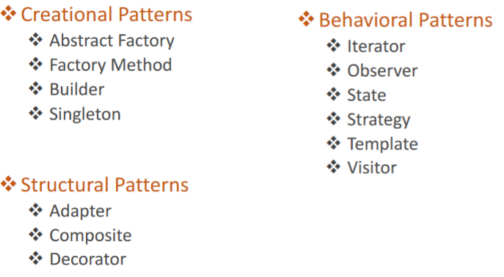

Figure 18 Design Pattern Overview

Figure 19 Builder Pattern Structure

Singleton Pattern: Creational design pattern that lets your ensure that a class has only one instance, while providing a global access point to this instance

* Solution:
  + Make default constructor private 🡪 Prevents other objects from using the **new** operator with the Singleton Class
  + Static creation method that acts as a constructor. Following calls after initial construction returns the cached object
  + Static construction method always returns the same object
  + Should put **synchronized** access modifier on getInstance() method for singleton class
* Use cases: When you only want one instance of a class
  + Log files
  + Potentially database class?
  + Model class?

Figure 20 Singleton Pattern

Visitor Pattern: Add behaviour in separate visitor class instead of integrating into existing class

* Problem: It should be possible to define a new operation for (some) classes of an object structure without changing the classes.
  + Client’s software could be dependent on instantiation of class so it would be a hassle to modify
* Solution: Pass in instantiated object into one of the visitor’s methods, providing necessary data to for the added behaviour in the visitor
  + Visitor class defines a set of methods for each different type of class

Figure 21 Visitor Pattern

* Element you are visiting must implement the Visitable/VisitorElement interface
  + Has accept(Visitor) method that calls the visitor v’s visit method
* Visitor:
  + Has visit method that adds behaviour
* Element / Visitable:
  + Has accept method that calls visit(element)
* Use case: Moving operations into visitor classes is beneficial when
  + Many unrelated on an object structure are required
  + Classes that make up the object structure are known to not change
  + New objects need to be added frequently
  + Algorithm involves several classes in the object structure 🡪 Manage all in one location
  + Works on several independent class hierarchies
* Limitation:
  + Extensions to class hierarchy require visit methods to be added